**Changes according to the feedback**

As the person who is responsible to handle the System admin role I have designed the UI prototype for the System admin role in the milestone 4. After getting the first feedback from the user, he required several changes to be done.

Below is the previously created prototype.

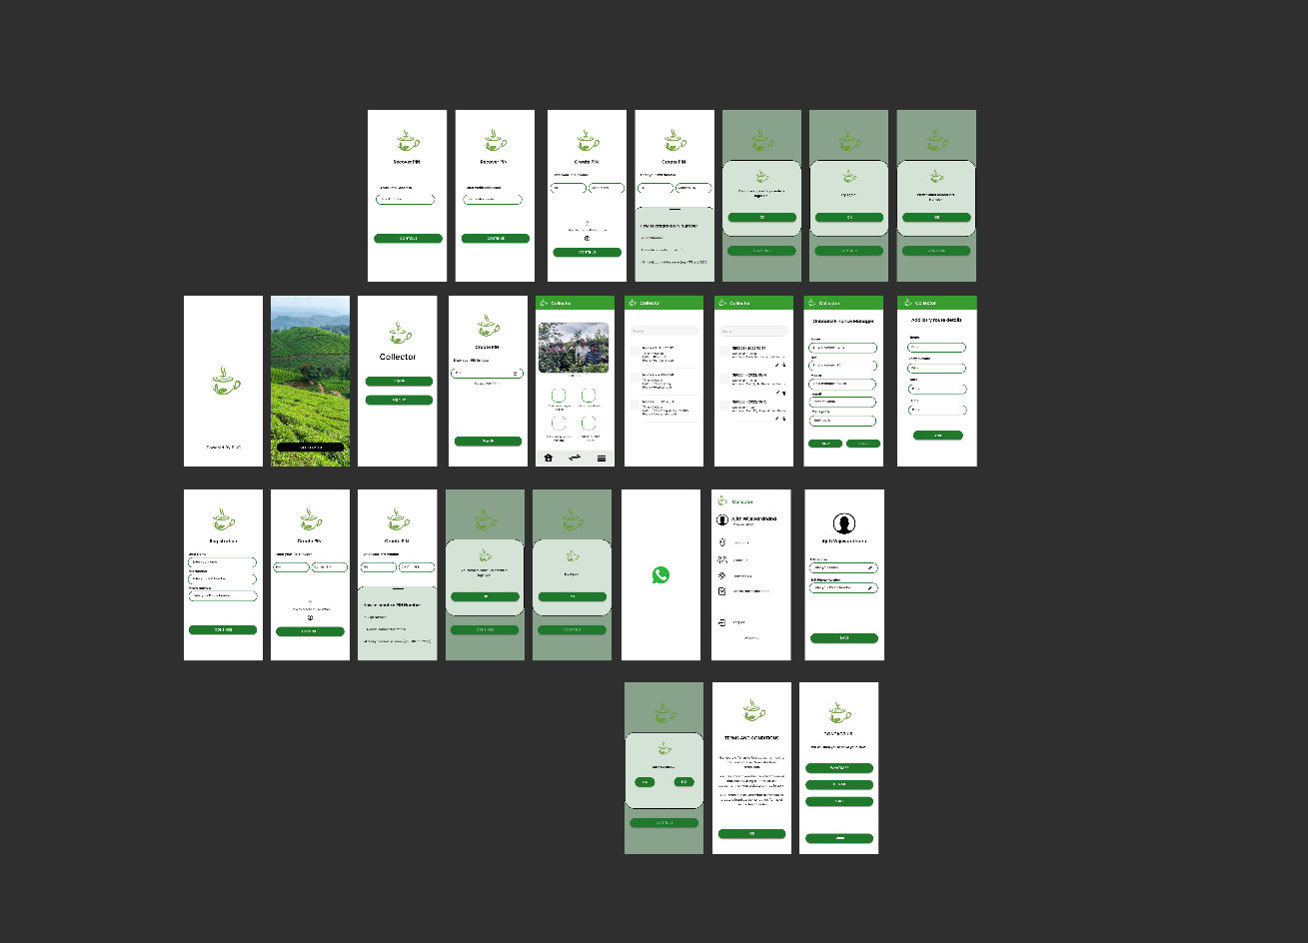

Figure - Previous UI prototype

Now next figure will show the edited UI prototype according to the user requirements.

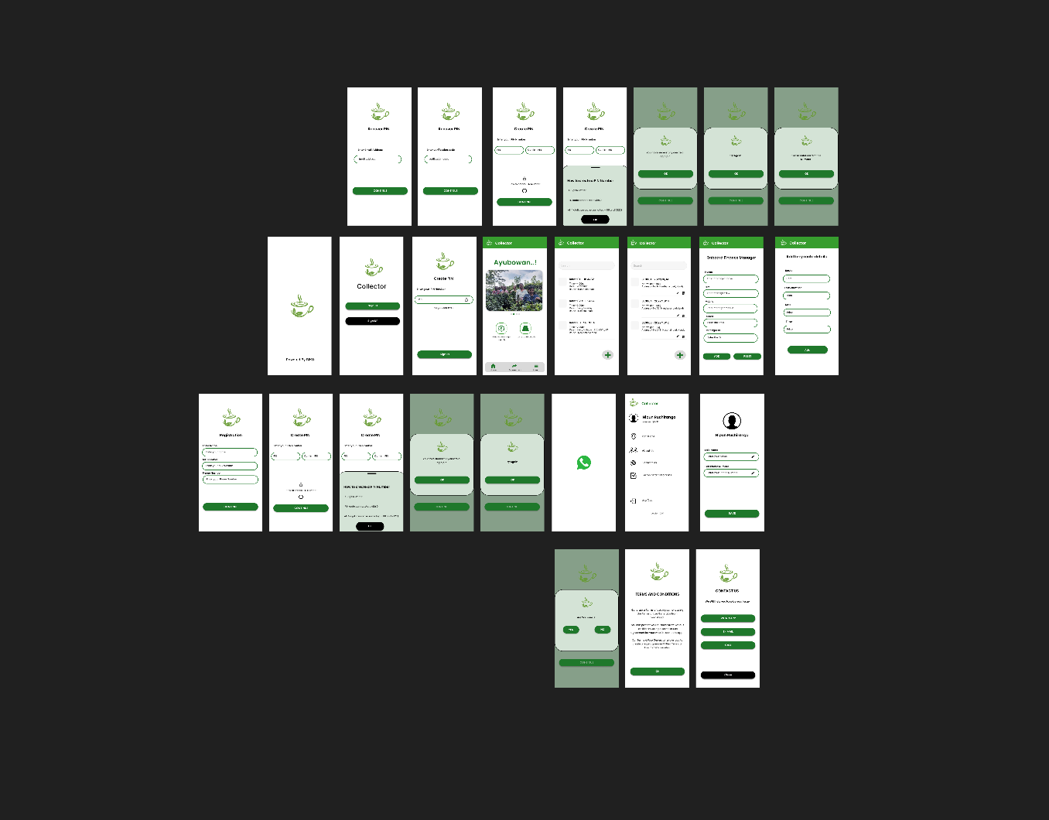

Figure - Prototype after user feedback

Two major changes have been requested by our client Mr . Nipun Ruchiranga.

They are,

* + A welcome greeting ‘Ayubowan’ was added to dashboard,
  + Onboarding finance manager, and Add lorry route details buttons were moved out from the dashboard.
  + Onboarding finance manager, and Add lorry route details buttons has been moved into Finance manager details and Lorry route details pages as two buttons with the plus vector without any word.

Therefore, I have done those two changes in the figure 2 and got feedback from Mr. Nipun Ruchiranga.

User feedback video link-